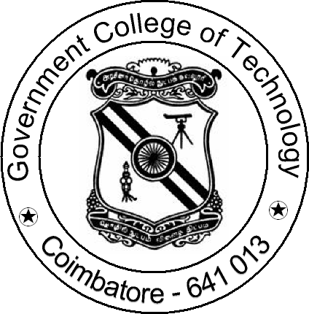

PROJECT
WORK

2021

DEPARTMENT OF INFORMATION TECHNOLOGY

GOVERNMENT COLLEGE OF TECHNOLOGY
(An Autonomous Institution affiliated to Anna University)
COIMBATORE - 641 013
ATTENDANCE MANAGEMENT SYSTEM USING FACE RECOGNITION

PROJECT SUBMITTED IN PARTIAL FULFILLMENT OF THE REQUIREMENTS FOR THE AWARD OF THE DEGREE OF BACHELOR OF TECHNOLOGY IN INFORMATION TECHNOLOGY
OF THE ANNA UNIVERSITY

Submitted by

ARUN I
(1718105)

RATHESH P
( 1718131)
SANJAI M
(1718134)

Under the Guidance of
Prof. T. Suguna M.Tech

Guidance of

